Building Statistics

General Building Data

Building Name - RIT Gordon Fieldhouse and Activities Center
Location and Site – Rochester, NY: Rochester Institute of Technology (RIT) Campus
Building Occupant Name – Rochester Institute of Technology
Occupancy or Function Types – Sports and Recreation, Education
Size – 160,000sf
Number of Stories Above Grade – 2
Primary Project Team –
RIT facilities, RIT
Architecture and Engineering by Cannon Design
www.cannondesign.com
Construction Management by The Pike Company
www.pikeco.com
Site/Civil Consulting by Clough, Harbour & Associates
www.cha-llp.com
Aquatic Consulting by Counsilman/Hunsaker & Associates
www.councilmanhunsaker.com
Acoustics Consulting by Cavanaugh Tocci Associates Inc.
www.cavtocci.com
Code Consulting by Robson & Woese, Inc.
www.robsonwoese.com

Dates of Construction – September 2002 – July 2004
Actual Cost Information – Overall Project Cost – $25,000,000
Project Delivery Method – Design Build
Building Envelope

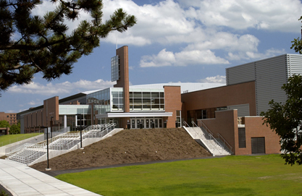
The fieldhouse’s façade, in conjunction with just about every other building on the Rochester Institute of Technology’s campus, is composed primarily of red brick – 132,000, to be exact. Unique to this building are the application of steel and aluminum accents. All of the fieldhouse’s windows utilize tempered and insulated double glazing. The building is 50 feet in height, with the signature tower structure rising an additional 17 feet with a 16 foot mast. The roof system uses EPDM rubber roof membrane for the flat roof areas which comprise about 56,000sf. The concave or “barrel” portion employed a Sarnafill system consisting of metal decking topped with dense board and thermoplastic PVC-polymer membrane to protect its some 66,300sf.

Construction

The Fieldhouse was constructed as a design-build project under the Pike Company. The original concept was conceived by RIT’s president, Dr. Albert J Simone, in 1992. Concept and Schematic Design took place between 1998 and 2001. The Design Development phase took place from November 2001 till June 2002. Construction Documents were completed in December of 2002, and construction commenced in August. The Fieldhouse was completed on May 17th, 2004, in time for Commencement, as planned. The 160,000sf project came in on time and on budget, with a final cost of 25 million dollars. This made the typical cost of RIT’s newest facility about $156.25/sf.
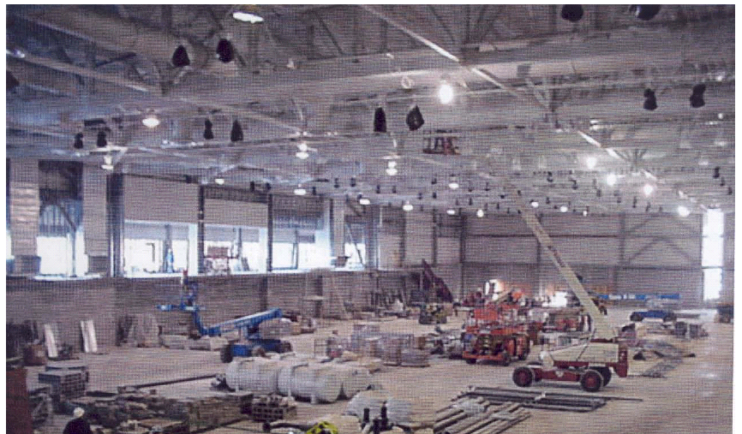

Mechanical

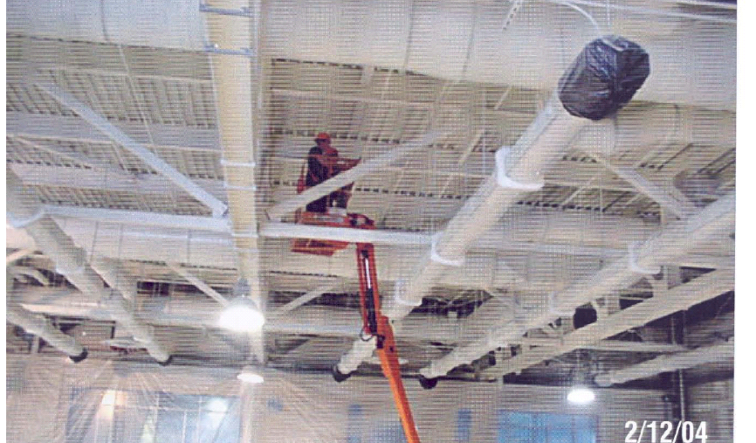
The Gordon Fieldhouse uses 9 Seasons 4 rooftop air handling units with supplies ranging from 3800 to 50,000cfm for environmental control in all areas except the two pools. The main fieldhouse area is controlled by two of these air handling units that work together to maintain the space’s heating, cooling and ventilation based upon temperature and CO₂ sensors. These units have direct exchange cooling, gas fired heating, economizers and variable speed drives. The team locker rooms are fed from one100% constant speed air handling unit and a hot water coil with terminal reheats in each space. Three efficient air pool units, two for the competition pool and one for the leisure pool maintain the pools’ environment – temperature, humidity, space pressure, etc. Each of the units is outfitted with economizers, hot water coils, refrigerant heat recovery coils and variable speed drives. The pools are heated independently by separate gas fired hot water boilers. The remainder of the building is serviced by two more Seasons 4 AHUs with a mixture of VAV boxes. Again the environments are maintained using temperature and CO₂ sensors. These units also are equipped with DX cooling, HW coils, economizers, and VFDs. The VAV boxes have a mix of fan powered, reheat, and cooling only. The reheat are HW coils fed from the building hot water plant, which is a pumping system with hot water fed from the existing gas boilers in the adjacent Life Sciences Center. All in all, the Fieldhouse utilizes some 7500 linear feet of copper and ductile iron pipe in various sizes to outfit the mechanical systems.

Structural

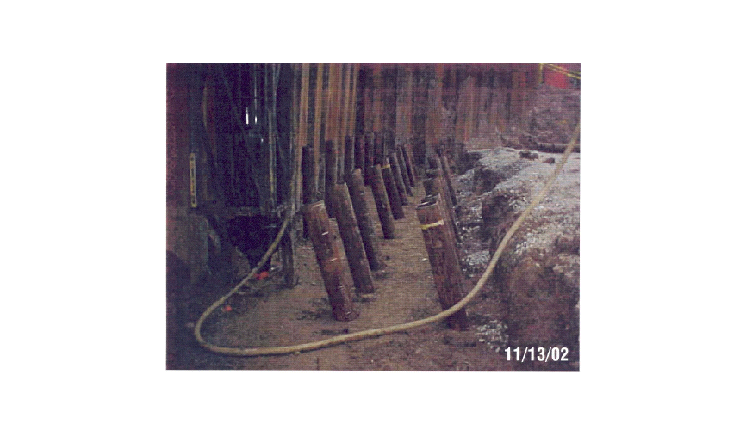
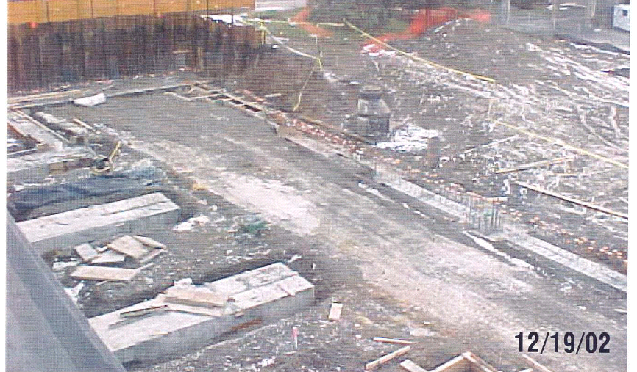
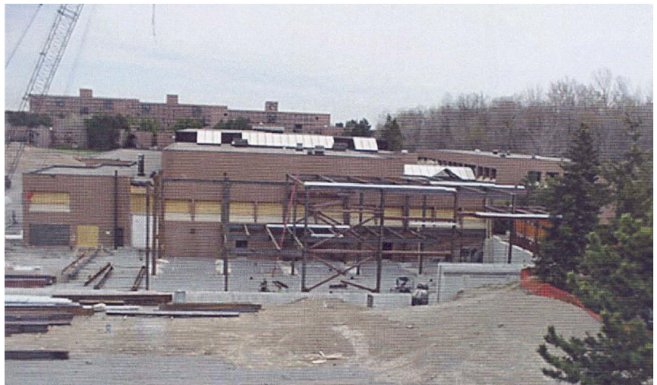
A composite floor system with composite beams and steel trusses was used for the structural system of the Gordon Fieldhouse. A slab-on-grade foundation is supported by 764 10” batter type, concrete filled pipe casings, each 27 feet deep into the underlying bedrock. 3000 cubic yards of concrete make up the footers, grade beams, and pile caps, while 2700 cubic y ards were used for the upper and lower floors, this concrete reinforced with 4000psi steel and a fiber mix called NOVOMESH. 1,500 tons of steel beams, girders and purlins in various sizes support 18 and 20 gauge acoustical decking. 50,000 concrete masonry units, some of which are load-bearing, complete the structural skeleton of the Fieldhouse.

Electrical

The Gordon Fieldhouse uses 480Y/277V and 277Y/208V standard radial distributing systems to serve its Electrical needs. The main service is 12.47 KV, provided from the Main Campus Distribution System. The underground high voltage electrical service enters the transformer vault of the building under the floor and goes to 15KV Interrupter medium voltage switchgear. From there, a series of two pad-mounted transformer banks with three one phase transformers each (conceived by RIT’s on staff Electrical Facilities Manager) serve as 2 large 3phase transformers to step down the high voltage into two separate low voltage services. The 480/277v system is used for building lighting and mechanical equipment. The 277/120v system services the wall receptacles and minor equipment. Both low voltage services are fed from overhead from the transformers into the switchgear room located adjacent to the transformer vault. The 480/277v system feeds into a 3000A 3phase, 4 wire switchboard, and the 277/120v system feeds into a 2500A 3 phase, 4 wire switchboard. Both switchboards are protected by 3000A draw-out type circuit breakers, and various circuit breakers protect the 26 total active branch circuits. One connected circuit feeds the emergency circuit panel for the Fieldhouse, which in turn supplies power for the Fire Alarm system, “blue phone” emergency exterior lights, Exit Signs, and Egress Safety Lighting. This circuit is also powered by a 480Y/277V 100KW natural gas fired, radiator cooled emergency generator set located on the second floor in the event that power is lost to the campus. A separate ATS is connected for other non-critical emergency loads including security, card access, telecom/data, selected 120v receptacles (for tools/lighting during power outages) selected exterior lighting, and minor mechanical equipment to prevent freezing.

Lighting

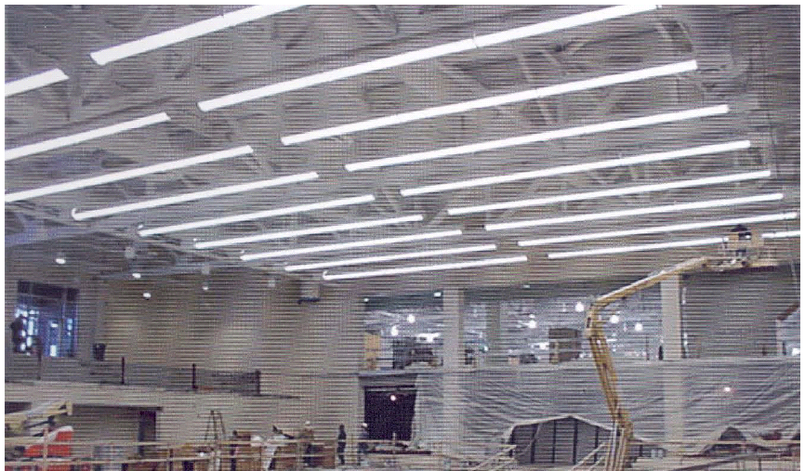
The Gordon Fieldhouse and Activities Center was designed with the intention of being able to house all sorts of campus activities, from indoor sports performance and practice to concerts and speakers to Commencement. Many lighting solutions were incorporated to meet the needs of each type of activity able to take place in this center. The 1,568 total luminaires are supplied by 277v power throughout the building. The majority of the general lighting in the Fieldhouse is achieved through the use of fluorescents, but some metal halide lamping is used for special applications, like the competition pool area and the actual fieldhouse itself. Other large spaces such as the fitness center and practice courts have typical, cost effective fluorescent lighting solutions employed. Energy efficiency was a large concern of both RIT and the electrical team designing the lighting, so almost every space is outfitted with either an occupancy sensor, a timer, or automatic shutoff.

The exterior of the building is lit with compact fluorescent sconces as well as metal halide linear fixtures to accentuate the Fieldhouse’s horizontal architectural elements. The signature tower’s glazed panels are backlit with metal halide piping fixtures. Site lighting is comprised of metal halide pole mounted fixtures and bollards, and compact fluorescent step lighting is employed at the main entrance.

Communications Systems

The adjacent Student Life Center’s infrastructure serves the new Fieldhouse’s telecommunications. A raceway system was installed, consisting of trunk riser conduits, outlet boxes and cover plates, and conduit stubs. Additionally a center spline cable tray system, data racks, cabinets, and equipment backboards complete the system.
The various communication systems housed in the Gordon Fieldhouse are:

- TV/Broadband Video
Television and video outlets are located in the main corridor of the building as well as in the fieldhouse, pools, fitness center and select other areas. Television and broadband video are utilized in the fitness center where six (6) banks of television sets are installed for entertainment purposes. Other applications of television are used in the security system as well as news feeds in the lobby.

- Data
Data service provides many useful operations, one of the most important being internet access. Data outlets are located all over the building, but concentrated in the various offices, reception areas, the building’s main corridor, the fieldhouse, pools, and fitness center.

- Telephone/Fax
In and out lines as well as fax capabilities are needed in almost every space in the fieldhouse for means of communication. In offices, phone booths, the fieldhouse, pools, and reception areas, telephone equipment is installed.

- Public Address/Annunciation
The public address system in the fieldhouse is an extension of the system in place in the adjacent Student Life Center. Supplementary amplifiers were installed at the existing equipment rack to accommodate the addition. Additional paging initiation locations were added throughout the building as the original initiation station from the adjoining building is at the equipment rack. Speakers are located in general public spaces such as corridors, lockers, and reception areas, and the paging system is also connection to the professional sound system installed in the pool areas, fitness center, and actual fieldhouse. Assisted listening systems are installed in areas of public assembly to comply with ADA code requirements. These systems are located in the main fieldhouse and competition pool area. Typical devices components that contribute to the public address system are microphones, preamplifiers, power amplifiers, racks, loudspeakers, loudspeaker horns, monitor panels, telephone paging adaptors, intercom stations, master station, volume control units (limiters/compressors, attenuators), battery back-up power unit/generator connections, and paging and system take-overs.

Fire Protection

The fire alarm system in the Fieldhouse is a continuation of the existing system in the adjacent Student Life Center building. A Simplex 4100 addressable fire alarm system located in the mechanical room of the adjacent building serves the two buildings. A transponder panel accommodates the extension into the new building. The expanded system monitors all alarm and trouble signals at both the existing annunciator panel and a new annunciator panel located in the Fieldhouse. The existing annunciator panel was upgraded to LCD type to match the new one. New and existing alarm and trouble signals are continually monitored by campus security in a remote building. The control panels consist of multiple alarm zones. Many types of equipment make up the fire alarm relay system, including: manual pull stations (high abuse and typical), strobe lights, speaker/horns, heat detectors, smoke detectors, duct smoke detectors, beam detectors (used in the fitness center), electromagnetic door holders, fire alarm control panel, field processing unit, fire alarm annunciator panel, and monitors. All areas are protected throughout with a hydraulically designed wet-pipe sprinkler system (per NFPA), specified to light hazard occupancy, with a density specified to be 0.10 GPM/sf over 1500sf. All primary steel members are sprayed with 3 hour Dow Corning – 3-6548 silicone RTV foam, and secondary members are sprayed with 2 hour foam by the same manufacturer to protect the Fieldhouse in the event of a fire.

Security

A raceway system for security wiring was installed to meet the needs of the Fieldhouse. RIT was responsible for furnishing and installing all security devices, wiring, and equipment. Security equipment includes card readers at access points, door lock devices, pull/override stations throughout the site, security cameras and camera monitoring devices.

